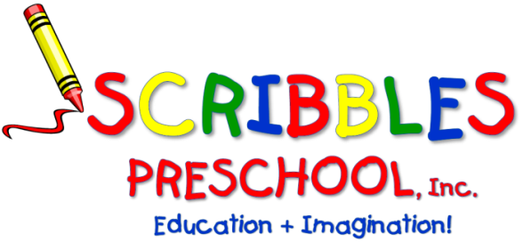

SCRIBBLES-N-BITS
Bring your “little bit” and enjoy time socializing and playing together. These informal sessions encourage friendship, fun, and exploration. You and your child will be participating in a variety of age appropriate, stimulating activities. Parenting issues and concerns are shared and discussed.

Songs/stories/finger plays/musical instruments, parachutes,
fine and gross motor activities and more!

FOR: 1-2 year old with adult

WHERE: Scribbles Preschool – Zebra Room

DATES: Jan. 11th , 18th, 25th, Feb.1st, 8th, 15th, Mar. 1st, 8th, 15, 22nd, 29th Apr. 5 (Make Up)

TIME: 9am to 10am

FEE: * $154.00 (Make check payable to Scribbles Preschool, Inc.)

* Any days you cannot attend, please indicate the days and deduct $14 per day.

STAFF: Meredith Giudice

Please keep top section & return the registration below prior to attendance.
- - - - - - - - - - - - - - - - - - - - - - - - - - - - - - - - - - - - - - - - - - - - - - - - - - - - - - - - - - - - - - - - - - - - - -
Scribbles ‘n Bits – 2nd Session 2022/2023
CHILD’S NAME: ___________________________________ PARENTS’ NAMES:____________________________________

ADULT’S NAME (who will be attending): __________________________________ ______ _________________________

HOME PHONE: _______________________________________ CELL PHONE: ______________________________________

ADDRESS: __________________________________________________________________________________________________

EMAIL: ___________________________________________________ AMOUNT ENCLOSED: $________________________

ALLERGIES: ______________________________________________CHILD’S DATE OF BIRTH: ________________________
48A Briarcliff Road, Mountain Lakes, NJ 07046
Phone: 973-334-1877 ▪ Fax: 973-810-1445
ScribblesPreschool@gmail.com ▪ ScribblesNJ.com

