SCRIBBLES PRESCHOOL, INC.
REGISTRATION INSTRUCTIONS FOR 2022-2023 SCHOOL YEAR
To register for Pre-K, submit the following items by mail (to our mailing address below) or to the school office. Submission to the office directly is the preferred method, especially for new families.
1. REGISTRATION FORM
Indicate your choice of class. Please be thorough with work numbers, emergency names, addresses, and phone numbers. Even if you work from your home, this information must be provided. We need two local people to contact in addition to parents in case of emergency. “Local” contacts are those who can reach the school within 20 minutes. Parents are always contacted first in the event of an emergency. The other people listed are contacted only if you are not available. The State requires full addresses and phone numbers for any people listed in this category.

2. REGISTRATION FEE
(Non-refundable) $ 100.00 fee per child payable at registration time. $50.00 for sibling enrolled at the same time..

3. TUITION DEPOSIT(S)
Required at time of Registration. See “Tuition Rates and Payment Schedule” in this Registration Packet. The Tuition Deposit holds your child’s space in a specific class. Each class has its own deposit, which is applied to the year’s total tuition for that class. It is $100 per day for each day the class meets per week.
Re: Lunch Bunch Plus: See “Tuition Rates and Payment Schedule”

Note: For families who enroll later in the year, tuition is pro-rated to the start date.

4. ENROLLMENT AGREEMENT
Sign and date the Registration Form in this Registration Packet. This is required in order to guarantee a placement.

5. AUTHORIZATION FOR FIELDTRIPS, NATURE WALKS, AND WEBSITE
Sign and date

6. PARENT PARTICIPATION FORM, AND HELP US GET TO KNOW YOUR CHILD FORM
Complete

7. MEDICAL
You and your physician must complete the state required Universal Child Health Record. In addition, other forms will need to be completed by you if your child: has asthma, has allergies, requires a medication to be given at school, or cannot be immunized for medical or religious reasons. Let us know at registration so we can provide you with these forms.

8. REGISTRATION REQUIREMENTS
Completed and signed forms: Registration Form, Parent Participation Form, Website Permission, Field Trip,
Cell Phone and Email Authorizations. Make certain that each form is signed.
Fees: Registration Fee, Tuition Deposit. Checks are to be made payable to Scribbles Preschool, Inc.

Note: A small photo of your child should be sent to the school in June 2022 or if registering later, send the photo prior to your child’s first day of class. You may mail it or email it to us. The medical information is due at
that time as well. Children cannot start class until medical information has been received, or medical or
religious exemptions have been submitted.

SCRIBBLES PRESCHOOL, INC. 48A Briarcliff Rd., Mountain Lakes, N.J. 07046

Phone: 973-334-1877 Fax: 973-810-1445 Email: scribblespreschool@gmail.com ScribblesNJ.com

2022/2023 CLASS OPTIONS

For Children 4 by October 1, 2022: Pre-K
8:40 a.m. - 12:00 p.m.
Pre-K: 4 mornings Mon/Tues/Wed/Thurs
Pre-K/Creative Drama/Five Senses 5 mornings Mon/Tues/Wed/Thurs/Fri

Specials for Pre-K:

LUNCH BUNCH – 12:00 TO 12:30PM
Extend the day with our Lunch Bunch Option. This is a 30-minute, supervised “bring your own lunch” program.
**Please remember we have a no nut policy.

LUNCH BUNCH ++ - ENRICHMENT CLASSES (See course descriptions attached) – 12:30 – 2:00pm
Extend the day with our Lunch Bunch Plus option (LB++), a 12:30 to 2:00pm class that includes *Lunch Bunch and a different enrichment class each day. Enrichment classes are scheduled as followed:
M-Travelin Tumblers & STEAM Team
T-Technology Toolbox & Book Nook
W-Melody Makers
Th-Around the world & PESA Sports
F-Kids Club

PRE-K ENRICHMENT CLASSES
Course Descriptions

Travelin’ Tumblers The program improves a child’s physical fitness, stimulates whole brain and body use, enhances motor skill
Development, sensory integration and self-esteem while also improving social and stress management
skills. Equipment such as balance beams, vaulters, ladders, hoops and wedges are
used to develop locomotor skills. Tumbling and Yoga are also incorporated.

STEAM Team Science, Technology, Engineering, Art and Math.
STEAM Team is a math enrichment program for children.
This program is a math class that allows children to explore with blocks, parquetry, geoboards, measuring cups,.etc The hands on approach leads to an understanding of math concepts and
provides opportunities to explore and practice critical thinking skills, problem solving skills, measurement,
tangram, tessellation, probability, and drawing structures.

Technology Students will develop and strengthen both technological and educational skills giving them a competitive
Toolbox, LLC advantage as they embark on new learning situations. The curriculum changes each year including software
and new projects.

Book Nook Book Nook is an afternoon enrichment program designed to enhance language development and promote
emerging literacy by focusing on several prominent children’s authors and illustrators. Each month
culminates with the children creating their own book based on the inspiration received from
the authors and illustrators studied.

Around the Around the World Adventure is an afternoon enrichment program that offers an introduction to geography
World and celebrates diversity. The children “travel” around the country and the world learning about habitats and
Adventure world cultures. They experience different customs, clothing, celebrations, learn about famous landmarks, etc.
Multicultural awareness is developed through hands on activities and intellectually stimulating experiences.

PESA/Sports
Clinic PESA is a sports enrichment class that introduces the students to different sports and the fundamentals that lie within those sports. The program enhances cognitive and motor skills through sports and exercise in a fun and safe environment.

Creative Creative Drama is a half year enrichment program providing language arts experiences and an opportunity for Drama / creative self-expression through dramatic play, and dramatic interpretation of literature, puppetry, and storytelling Five Senses using scenery, props and costumes. Five Senses is an enrichment program than enhances the awareness and
perception of the environment through the use of the senses: smell, taste, hearing, touch, sight. A major component is science. Through the discovery method, children develop confidence and critical thinking skills. This class is part of our five day Pre-K program that meets on Friday mornings.

Kidsclub The Kidsclub program provides an added dimension in preschool programming. All classes are theme- based,
varied, and fun. The Kidsclub modules include: Yummy Tummy, Puppet Party, Wacky Woodworking, Blast Off, Squish and Squash, Mango Tango Café, Class with Trash, Digging in the Stone Age.

2022 – 2023 TUITION RATES AND PAYMENT SCHEDULE
$100.00 Non-Refundable Registration Fee Per Child
CLASS CODES | # OF DAYS PER WK | TOTAL TUITION PER YEAR | DEPOSIT | JUNE  6/1/22 | OCT  10/1/22 | DEC  12/1/22 |  | FEB  2/1/23 | APRIL  4/1/23
Pre-K | 4 | 6425 | 400 | 1205 | 1205 | 1205 |  | 1205 | 1205
Pre-K | 5 | 8005 | 500 | 1501 | 1501 | 1501 |  | 1501 | 1501

Lunch Bunch (LB) is available Monday through Friday for children in the Threes and Pre-K classes. Children can enroll for 1, 2, 3, 4, or 5 days per week. The LB tuition is payable in (2) installments. The first is due at registration and covers LB from Sept. 2022 through Jan. 2023. The second is due Feb.1, 2023 and covers LB from Feb. 2023 through June 2023. Lunch Bunch will be billed separately from class tuition.

 | # DAYS PER WK | YEARLY TUITION | DEPOS.  AT REG. | FEB  2/1/23
Lunch Bunch | 1 | 286 | 143 | 143
Lunch Bunch | 2 | 562 | 281 | 281
Lunch Bunch | 3 | 840 | 420 | 420
Lunch Bunch | 4 | 1118 | 559 | 559
Lunch Bunch | 5 | 1394 | 697 | 697

Lunch Bunch Plus (LB++) is available Monday through Friday. Children can enroll for 1, 2, 3, 4, or 5 days per week.
The LB++ tuition is payable in (5) installments. Lunch Bunch Plus + will be billed separately from class tuition.

 |  |  |  | PAYMENT DUE
 | # DAYS PER WK | TUITION PER YEAR | DEPOS.  AT REG. | OCT  10/1/22 | DEC  12/1/22 | FEB  2/1/23 | APRIL  4/1/23
LB Plus + | 1 | 1356 | 200 | 289 | 289 | 289 | 289
LB Plus + | 2 | 2688 | 400 | 572 | 572 | 572 | 572
LB Plus + | 3 | 4028 | 600 | 857 | 857 | 857 | 857
LB Plus + | 4 | 5360 | 800 | 1140 | 1140 | 1140 | 1140
LB Plus + | 5 | 6708 | 1000 | 1427 | 1427 | 1427 | 1427

Enrollment Agreement for 2022- 2023 School Year – Retain this for your records
1. A $ 100.00 non-refundable registration fee per child enrolled is due at registration. $50.00 for second sibling enrolled at the same time.
2. A tuition deposit is also due for each child at registration.
3. Tuition Fees are amortized into several installment payments as indicated on the tuition schedule page. Different installment payment options can be arranged in advance for those who are registering later in the school year once classes have already begun, for those requiring financial assistance and for siblings attending the same year.
4. Tuition fees are refundable only as follows:
a) For only those children in our Pre-K class whose parents are undecided about Kindergarten entrance, a total tuition refund will be given up until May 1, 2022, provided the child is withdrawn in writing by that date for that particular reason.
b) A pro-rated tuition refund is given to parents only under the following circumstances:
- If it is determined by the Scribbles school administration and faculty that the child is a danger to himself and others and must be withdrawn from the school immediately.
- If a child is having significant difficulties at school, i.e., separating from parents, adjusting to the program, etc., even after attending for several weeks consistently, and is asked to be withdrawn.
- If a child with special needs must be withdrawn due to a lack of availability of additional support personnel as needed, as determined by the Scribbles administration, staff, consultation with professionals and parents, and/or the IEP established in conjunction with the child’s sending school district.
- If we feel we cannot meet your child’s needs after implementing various reasonable interventions over a period of time, and we require withdrawal from the school.
- Credits or pro-rated refunds for illness, vacation, relocation, etc. are not given for any reason except in the rare circumstances of documentation of a catastrophic illness that creates a major financial hardship for the family. Pro-rated refunds are not given for family vacation, regular illness, or if the school needs to have a delayed opening or cancellation due to weather conditions as determined by the Mountain Lakes Public School System in conjunction with the Mountain Lakes Board of Education and Police Department.
Sibling Discount Policy
A sibling discount of 10% is available for siblings concurrently attending one of the regular classes. The discount is applied to the tuition of the child who attends fewer days and deducted from each installment.
Misc Fees
1. Late pick-up is not an acceptable option on a regular basis. Only an unavoidable emergency situation will be accepted. If at all possible, call the school if you will be late. This way we can minimize your child’s distress. It is unfair to both your child and staff to be late with any frequency. If the situation is abused, you will be assessed an additional $10.00 per 10 minutes. Parents of classified students whose school districts are late in paying tuition are responsible for working this issue out with their own child study team and school district.
2. Returned Check Fee: A charge of $40.00 for any check returned will be assessed to cover our bank charges and extra administrative costs.
Special Financial Arrangements / Financial Assistance
Scribbles does not want finances to keep your child from our school. We try to meet family circumstances as best as we can. Please attach a letter to your registration form if you require an alternate Tuition Schedule allowing for smaller, more frequent payments or any other special consideration. Financial assistance is available through the Lil Ashton Scholarship Fund. To qualify, documentation of income under $65,000 per year or documentation of personal catastrophic illness expenses for those families with higher incomes is required. A copy of the family’s most recent W-2 form may be required as proof of financial need. The request for financial assistance must be made in writing at the time of registration. Misrepresentation of gross household income will result in retroactive charges for reduced tuition.

Billing
Scribbles will email and send reminder notices regarding tuition approximately 2 weeks prior to the due dates as listed on the tuition schedule once the school year begins. Siblings will receive just (1) notice that indicates the installment due for each child. Families will receive these notices in their child’s cubby. Tuition payments due are not dependent upon billing, so please refer to your tuition schedule in your registration packet. You may mail payments or bring them to the school office. If no one is in the office, leave papers and payment in a sealed envelope in the wall file by the office door. If the building is locked, mailbox is located by the double door entrance closest to the office. Do not leave any papers or payments on the desk or counters.

Waiting List
No deposit is required to go on a waiting list for a class that is filled. Parents will be contacted if an opening occurs and will have the option of registering their child at that time. Should the opening occur after school has started, tuition will be prorated based on the start date.

Registration constitutes an obligation on the part of the parents/guardians for the payment of annual fees for the entire academic year, with the only exceptions being those as stated above and on the “Tuition and Payment Schedule” page. I hereby agree to meet the tuition obligations as outlined.

I give my child permission to engage in all prescribed activities, except as noted by me and the examining physician. In the event I cannot be reached in an emergency, I hereby authorize the Scribbles Staff to allow possible emergency care, to call an ambulance, and to permit hospitalization and treatment for my child.

Enrollment Agreement for the 2022 – 2023 School Year
1. A $100.00 non-refundable registration fee per child enrolled is due at registration. $50.00 for second sibling enrolled at the same time.
2. A tuition deposit (see Tuition Schedule, page 5) is also due for each child at registration.
3. Tuition Fees are amortized into several installment payments as indicated on the tuition schedule page. Different installment payment options can be arranged in advance for those who are registering later in the school year once classes have already begun, for those requiring financial assistance and for siblings attending in the same year.
4. Tuition fees are refundable only as follows:
a) For only those children in our Pre-K class whose parents are undecided about Kindergarten entrance, a total tuition refund will be given up until May 1, 2022, provided the child is withdrawn in writing by that date for that particular reason.
b) A pro-rated tuition refund is given to parents only under the following circumstances:
- If it is determined by the Scribbles school administration and faculty that the child is a danger to himself and others and must be withdrawn from the school immediately.
- If a child is having significant difficulties at school, i.e., separating from parents, adjusting to the program, etc., even after attending for several weeks consistently, and is asked to be withdrawn.
- If a child with special needs must be withdrawn due to a lack of availability of additional support personnel as needed, as determined by the Scribbles administration, staff, consultation with professionals and parents, and/or the IEP established in conjunction with the child’s sending school district.
- If we feel we cannot meet your child’s needs after implementing various reasonable interventions over a period of time, and we require withdrawal from the school.
- Pro-rated refunds are not given for family vacation, regular illness, or if the school needs to have a delayed opening or cancellation due to weather conditions as determined by the Mountain Lakes Public School System in conjunction with the Mountain Lakes Board of Education and Police Department.
Sibling Discount Policy
A sibling discount of 10% is available for siblings concurrently attending one of the regular classes. The discount is applied to the tuition of the child who attends fewer days and deducted from each installment.
Misc Fees
1. Late pick- up is not an acceptable option on a regular basis. Only an unavoidable emergency situation will be accepted. If at all possible, call the school if you will be late this way we can minimize your child’s distress. It is unfair to both your child and staff to be late with any frequency. If the situation is abused, you will be assessed an additional $10.00 per 10 minutes. Parents of classified students whose school districts are late in paying tuition are responsible for working this issue out with their own child study team and school district.
2. Returned Check Fee: A charge of $40.00 for any check returned will be assessed to cover our bank charges and extra administrative costs.
Special Financial Arrangements/Financial Assistance
Scribbles does not want finances to keep your child from our school. We try to meet family circumstances as best as we can. Please attach a note to your registration form if you require an alternate Tuition Schedule allowing for smaller, more frequent payments or any other special consideration. Financial assistance is available through the Lil Ashton Scholarship Fund. To qualify, documentation of income under $65,000 per year or documentation of personal catastrophic illness expenses for those families with higher incomes is required. A copy of the family’s most recent W-2 form may be required as proof of financial need. The request for financial assistance must be made in writing at the time of registration. Misrepresentation of gross household income will result in retroactive charges for reduced tuition.
Billing
Scribbles will email and send reminder notices regarding tuition approximately 2 weeks prior to the due dates as listed on the tuition schedule once the school year begins. Siblings will receive just (1) notice that indicates the installment due for each child. Remember to check your child’s cubby and backpack for this! Tuition payments due are not dependent upon billing, so please refer to your tuition schedule in your registration packet. You may mail payments or bring them to the school office. If no one is in the office, leave papers and payment in a sealed envelope in the wall file by the office door. If the building is locked, mailbox is located by the double door entrance closest to the office. Do not leave any papers or payments on the desk or counters.

Waiting List
No deposit is required to go on a waiting list for a class that is filled. Parents will be contacted if an opening occurs and will have the option of registering their child at that time. Should the opening occur after school has started, tuition will be prorated based on the start date.

Registration constitutes an obligation on the part of the parents/guardians for the payment of annual fees for the entire academic year, with the only exceptions being those as stated above and on the “Tuition and Payment Schedule” page. I hereby agree to meet the tuition obligations as outlined.
I give my child permission to engage in all prescribed activities, except as noted by me and the examining physician. In the event I cannot be reached in an emergency, I hereby authorize the Scribbles Staff to allow possible emergency care, to call an ambulance, and to permit hospitalization and treatment for my child.

Date: _______________________ Signature of Parent/Guardian: _________________________________

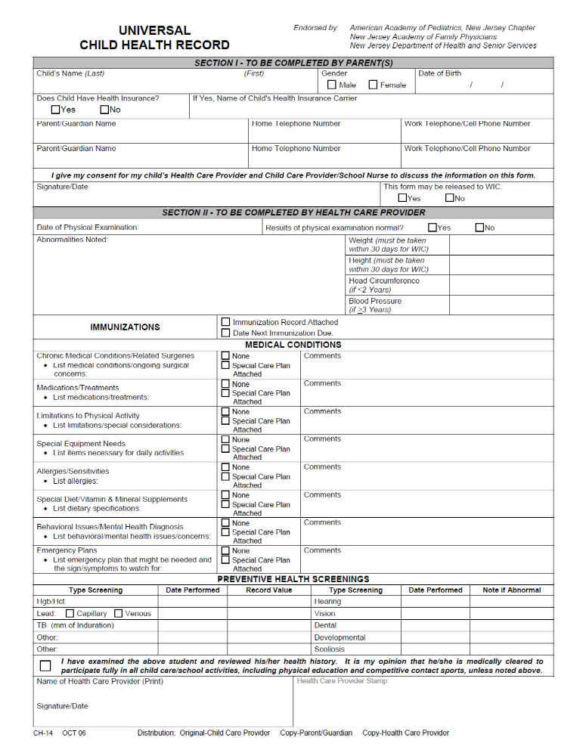

SCRIBBLES PRESCHOOL, INC.
Office use only
Class
Date
Deposit
Allergy

Registration Form 2022—2023

CLASS OPTIONS: Please indicate choices.
Pre-K 8:40 a.m. – 12:00 p.m.
_____ M, T, W, Th _____ M, T, W, Th, F*
*Creative Drama/Five Senses

Lunch Bunch (LB) 12:00 p.m. – 12:30 p.m. Lunch Bunch Plus (LB++) 12:00 p.m. – 2:00 p.m.
Circle Day(s): M T W Th F Circle Day(s): M T W Th F

+---------------------------

CHILD’S NAME |  |  |  |  |  |  |  | Date of Birth  (mm/dd/yy) |  |  |  |  |  | Sex  (M/F)
Mother/Guardian |  |  |  |  |  | Father/Guardian
Tel# |  | Cell# |  |  |  | Tel# |  |  |  |  | Cell#
Address |  |  |  |  |  | Address
City |  | State |  |  | Zip | City |  |  |  |  | State |  | Zip
Mom Email: |  |  |  |  |  | Dad Email:
Employer |  |  |  |  |  | Employer
Address |  |  |  |  |  | Address
City |  | State |  |  | Zip | City |  |  |  |  | State |  | Zip
Tel# |  |  |  |  |  | Tel#
Pediatrician’s Name: Tel#:
Address |  |  |  |  |  | City |  |  |  |  | State |  | Zip
Other Children in Family (list on separate sheet if necessary):
Name |  |  |  | Name |  |  |  |  | Name
Date of Birth  (mm/dd/yy) | Sex  (M/F) |  |  | Date of Birth  (mm/dd/yy) |  |  | Sex  (M/F) |  | Date of Birth  (mm/dd/yy) |  |  |  |  |  | Sex  (M/F)
Persons to contact in an Emergency (other than parents)–e.g., friends, neighbors, etc. We need TWO (required by law): These must be LOCAL (within 20 minutes of school):
Name1 |  |  |  |  |  | Tel# |  |  |  | Cell#
Address |  |  |  |  |  | City |  |  |  |  | State |  | Zip
Name2 |  |  |  |  |  | Tel# |  |  |  | Cell#
Address |  |  |  |  |  | City |  |  |  |  | State |  | Zip
I hereby authorize the following adults to pick up my child from Scribbles Preschool throughout the year:
Name |  |  |  |  |  | Tel# |  |  |  | Cell#
Address |  |  |  |  |  | City |  |  |  |  | State |  | Zip
Name |  |  |  |  |  | Tel# |  |  |  | Cell#
Address |  |  |  |  |  | City |  |  |  |  | State |  | Zip
Date: ________________ Signature of Parent/Guardian: ________________________________________ ppParent/Guardian:____________________________________________________________________

SCRIBBLES PRESCHOOL

PARENT PARTICIPATION

Dear Parents:
We welcome the involvement of parents in our Preschool. Below is a list of ways parents have chosen to help us in the past. Please feel free to check off as many categories as you like. If you are unavailable to participate, just complete the top of the form. Also, please add any other ways you would like to get involved. We look forward to seeing you throughout the year, having fun, and working with you for the benefit of the children.

Your Name: ______________________________________ Telephone: _________________________

Child’s Name and Class: _______________________________________________________________

IN CLASS WITH CHILDREN

_____ 1. Arts/crafts activity or demonstration
_____ 2. Baking projects
_____ 3. Music idea and experience from you
_____ 4. Science or nature activity brought in by you
_____ 5. Community helper visit (physician, nurse, police officer, fire fighter, etc.)
_____ 6. Other occupation visit (pilot, artist, musician, etc.)
_____ 7. Something from your special work or hobby which the children may enjoy hearing about or trying
_____ 8. Ethnic knowledge (customs, holidays, cooking, etc.)
_____ 9. Substitute Teaching

For some of the following categories, we’ll be forming committees so you will get to meet others and have fun as well! Let us know if you’d consider heading a particular committee. Thanks so much.

OTHER INVOLVEMENT

_____ 1. Photographing or video recording
_____ 2. Hospitality (providing refreshments for various school functions)
_____ 3. Publicity (designing, distributing posters for school events and/or fund-raisers)
_____ 4. Speaking at parent education event (examples: child psychologist, speech pathologist, learning specialist, pediatrician, dietitian, etc.)
_____ 5. Sewing (cushion covers, etc.)
_____ 6. Fundraiser help – indicate which
____brainstorming _____ refining ideas _____ chairing _____ assisting in some capacity
_____ 7. Your idea for parent education:
_______________________________________________________________________________
_____ 8. Other ideas:
_______________________________________________________________________________
_______________________________________________________________________________

SCRIBBLES PRESCHOOL, INC. 48A Briarcliff Rd., Mountain Lakes, N.J. 07046

Phone: 973-334-1877 Fax: 973-810-1445 Email: scribblespreschool@gmail.com ScribblesNJ.com

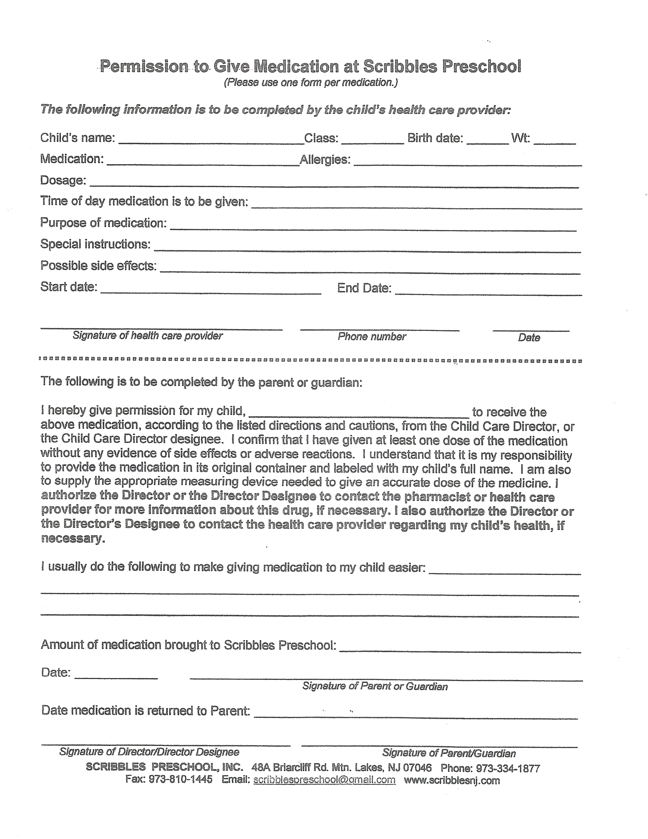SCRIBBLES PRESCHOOL
AUTHORIZATION FORM

Website Authorization
As you may know, Scribbles has a website, www.ScribblesNJ.com. We wish to include some photos of the children in action. (The children will not be identified by name.) Please let us know whether or not we have your permission for your child to be on our website by completing the appropriate section below. Return it with your registration materials. A separate form must be completed for each child enrolled. Thank you.

I do / I do not give permission for my child ____________________________________ in class ___________ to
(circle one) Name
be included on the Scribbles website.

____________________________________ ____________
Parent’s Signature Date

Nature Walk and Field Trip Authorization

Our Pre-K classes go on Nature Walks and take field trips off site throughout the year to such places as:
the Morris Museum, Mountain Lakes Post Office, Island Beach, the Mountain Lakes Firehouse, the Planetarium at CCM in Randolph, Brookhollow Farm in Boonton Twp., etc.

I understand that I will be notified in advance of any field trip, and that I will be asked to sign a consent form for each trip.
A car seat or booster seat must be provided by the family on day of the trip, as required by State Law.

I understand that any parent who volunteers to drive on a field trip will provide the Scribbles school office with proof of a valid driver’s license and auto insurance.

My child has permission to go on nature walks and/or field trips.

_________________________________________________________ ___________________
Parent’s Signature Date

Cell Phone Number and Email Address Disclosure Authorization

I do / I do not give permission to include my cell phone number on parent class lists.
(circle one)

I do / I do not give permission to include my email address on parent class lists.
(circle one)

_________________________________________________________ ___________________
Parent’s Signature Date

